Alice in Wonderland, Lesson 2 ‘Alice’ HAVO/VWO
- Read the piece of text about ‘The history behind the story’.
a. Have a look on the internet and find out what other story, written by Lewis Carrol, is also based on Alice Liddell.
-
b. Have another look on the internet and find out how Lewis Carrol (or Charles Dodgson) met Alice Liddell.
-
- Read the text ‘Alice in Wonderland, Chapter 2’ and write down 20 difficult words with their translation.
English | Dutch | English | Dutch

- Answer these questions about the text.
- At one point, the duchess starts to sing a lullaby to her ‘pig’. What is a lullaby?
-
- Alice asks the Cheshire Cat which way she has to go. They start to have a conversation and the Cat says 'Oh, you're sure to do that,' said the Cat, 'if you only walk long enough.' Explain, in your own words, what he means.
-
- Alice says: 'the March Hare will be much the most interesting, and perhaps as this is May it won't be raving mad — at least not so mad as it was in March.' Why does she expect the Hare to be less mad in May? You may use the internet to answer this question.
-
- To be ‘as mad as a March hare’ is an English expression. Find out what this expression means.
-
- At the end of the story, Alice wishes she had gone to the hatter. Why?
-

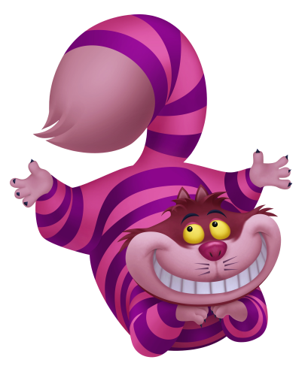
- Have a look at the video about the Cheshire Cat and answer the questions.
https://www.youtube.com/watch?v=G4fHre-yRPY
- Write down 2 similarities between the story and the video.
-
-
- Write down 2 differences between the story and the video.
-
-
Disney’s Alice in Wonderland HAVO
- When was the original story ‘Alice in Wonderland’ written?
-
- When did Disney make its film ‘Alice in Wonderland’?
-
- Who did the voice for Alice?
-
- Who did the voice for the Mad Hatter?
-
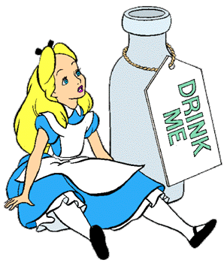

Old and modern VWO
Have a look at this short video of Tim Burton’s Cheshire cat.
https://www.youtube.com/watch?v=W1St7sRFEEE
- What are similarities between Disney’s cat and Tim Burton’s cat?
-
- What is the biggest difference between the two cats? Pay attention to the atmosphere in the two clips.
-
